**EE219 Project 2 – Classification Analysis**– *Shubham Mittal* (104774903), *Swati Arora* (404758379), *Anshita Mehrotra* (904743371)

**Dataset and Problem Statement:**

1. The number of documents in ***Recreational Activity*** are ***3979***.

The number of documents in ***Computer Technology*** are ***3903***.  
Histogram of the number of documents per topic is shown below. We see that the distribution of the training samples is almost the same, except for tapering down on the sides for a few categories (which are not included in the later questions).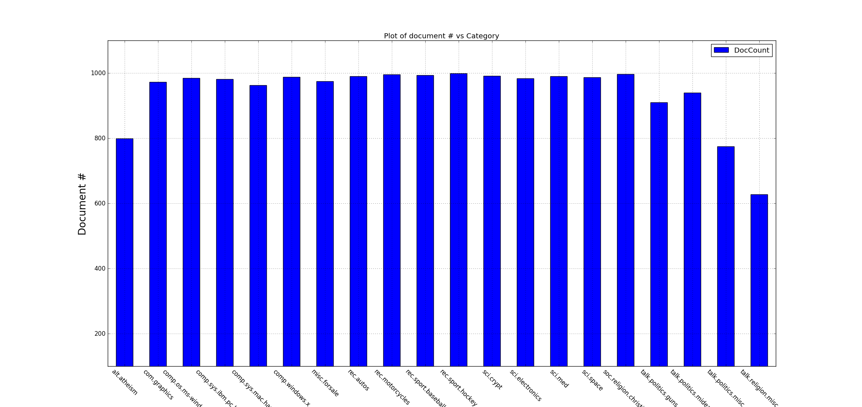

**Modeling Text Data and Feature Extraction:**

1. The final number of terms extracted equals **70465**
2. The most significant terms for the different classes are as follows:

|  |  |  |  |  |  |  |  |
| --- | --- | --- | --- | --- | --- | --- | --- |
| **comp.sys.ibm.pc.hardware** | | **comp.sys.mac.hardware** | | **misc.forsale** | | **soc.religion.christian** | |
| **Words** | **Counts** | **Words** | **Counts** | **Words** | **Counts** | **Words** | **Counts** |
| *edu* | 1423 | *edu* | 1899 | *edu* | 1751 | *god* | 2577 |
| *Drive* | 1403 | *line* | 1073 | *00* | 1215 | *christian* | 1760 |
| *line* | 1101 | *mac* | 1020 | *line* | 1044 | *edu* | 1638 |
| *com* | 1080 | *subject* | 997 | *subject* | 1008 | *church* | 937 |
| *subject* | 1024 | *organ* | 934 | *Sale* | 955 | *subject* | 1176 |
| *use* | 1010 | *use* | 803 | *Organ* | 981 | *jesus* | 904 |
| *scsi* | 1000 | *quadra* | 270 | *univers* | 564 | *Homosexu* | 653 |
| *organ* | 972 | *appl* | 664 | *com* | 548 | *peopl* | 1073 |
| *card* | 769 | *Problem* | 611 | *new* | 542 | *Sin* | 795 |
| *ide* | 573 | *centri* | 223 | *10* | 509 | *Line* | 1052 |

**Learning Algorithms**

We first load the training and test dataset for the categories which need to be classified. Classifiers need to classify documents into two classes: Computer technology and Recreational activity.

**Computer technology (indicated as class 0)** include subcategories *comp.graphics , comp.os.ms-windows.misc, comp.sys.ibm.pc.hardware, comp.sys.mac.hardware*.

**Recreational activity (indicated as class 1)** include subcategories *rec.autos, rec.motorcycles, rec.sport.baseball, rec.sport.hockey*

**Ans e) Linear Support Vector Machine**

In this problem, Linear Support Vector Machine is trained to fit the test dataset. We used linear kernel to train the classifier. Statistics obtained are as follows:

**Confusion matrix**

|  |  |  |
| --- | --- | --- |
|  | **Predicted : Computer technology (Class 0)** | **Predicted :** Recreational activity (Class 1) |
| **Actual : Computer technology (Class 0)** | 1501 | 59 |
| **Actual** : Recreational activity(Class 1) | 38 | 1552 |

**Recall and Precision score**

|  |  |  |  |  |
| --- | --- | --- | --- | --- |
| Class | Precision | Recall | F1-score | Support |
| 0 | 0.98 | 0.96 | 0.97 | 1560 |
| 1 | 0.96 | 0.98 | 0.97 | 1590 |

**avg / total** 0.97 0.97 0.97 3150

**Accuracy: 0.969206349206 (96.92%)**

**ROC Curve**



**Ans f) Soft Margin Support Vector Machine with 5-fold cross validation**

In this problem, Soft margin Support Vector Machine with different values of gamma is trained to fit the test dataset. It is done in order to minimize training error and avoid overfitting of data. To obtain best results, 5-fold cross validation is performed.

The best results were obtained at gamma = 0.1

**Confusion matrix**

|  |  |  |
| --- | --- | --- |
|  | **Predicted : Computer technology (Class 0)** | **Predicted :** Recreational activity (Class 1) |
| **Actual : Computer technology (Class 0)** | 1501 | 59 |
| **Actual** : Recreational activity(Class 1) | 38 | 1552 |

**Recall and Precision score**

|  |  |  |  |  |
| --- | --- | --- | --- | --- |
| Class | Precision | Recall | F1-score | Support |
| 0 | 0.98 | 0.96 | 0.97 | 1560 |
| 1 | 0.96 | 0.98 | 0.97 | 1590 |

**avg / total** 0.97 0.97 0.97 3150

**Accuracy: 0.969206349206 (96.92%)**

**ROC Curve**



**Ans g) Naïve Bayes Algorithm**

**Confusion matrix**

|  |  |  |
| --- | --- | --- |
|  | **Predicted : Computer technology (Class 0)** | **Predicted :** Recreational activity (Class 1) |
| **Actual : Computer technology (Class 0)** | 1293 | 267 |
| **Actual** : Recreational activity(Class 1) | 56 | 1534 |

**Recall and Precision score**

|  |  |  |  |  |
| --- | --- | --- | --- | --- |
| Class | Precision | Recall | F1-score | Support |
| 0 | 0.96 | 0.83 | 0.89 | 1560 |
| 1 | 0.85 | 0.96 | 0.90 | 1590 |

**avg / total** 0.90 0.90 0.90 3150

**Accuracy : 0.89746031746 (89.74 %)**

**ROC Curve**



**Ans h) Logistic Regression Classifier**

In this problem, Logistic Regression Classifier with different penalty function is trained to fit the test dataset.

Statistics for Logistic Regression Classifier with **‘l2’ penalty function** are as follows:

**Confusion matrix**

|  |  |  |
| --- | --- | --- |
|  | **Predicted : Computer technology (Class 0)** | **Predicted :** Recreational activity (Class 1) |
| **Actual : Computer technology (Class 0)** | 1486 | 74 |
| **Actual** : Recreational activity(Class 1) | 35 | 1555 |

**Recall and Precision score**

|  |  |  |  |  |
| --- | --- | --- | --- | --- |
| Class | Precision | Recall | F1-score | Support |
| 0 | 0.98 | 0.95 | 0.96 | 1560 |
| 1 | 0.95 | 0.98 | 0.97 | 1590 |

**avg / total** 0.97 0.97 0.97 3150

**Accuracy: 0.965396825397 (96.53 %)**

**ROC Curve**



Statistics for Logistic Regression Classifier with **‘l1’ penalty function** are as follows:

**Confusion matrix**

|  |  |  |
| --- | --- | --- |
|  | **Predicted : Computer technology (Class 0)** | **Predicted :** Recreational activity (Class 1) |
| **Actual : Computer technology (Class 0)** | 1491 | 69 |
| **Actual** : Recreational activity(Class 1) | 35 | 1555 |

**Recall and Precision score**

|  |  |  |  |  |
| --- | --- | --- | --- | --- |
| Class | Precision | Recall | F1-score | Support |
| 0 | 0.98 | 0.96 | 0.97 | 1560 |
| 1 | 0.96 | 0.98 | 0.97 | 1590 |

**avg / total** 0.97 0.97 0.97 3150

**Accuracy: 0.966984126984 (96.69 %)**

**ROC Curve**



Using ‘L1’ penalty function provides slight improvement in accuracy.

**Comparison**



As seen in the figure, SVM and Logistic Regression classify documents with almost similar accuracy while Naïve Bayes is less accurate for this type of classification as compared to other two algorithms.

**MultiClass Classification**

**Ans(i) – Naïve Bayes and SVM**

The classifiers were trained for the following classes:

1. comp.sys.ibm.pc.hardware
2. comp.sys.mac.hardware
3. misc.forsale
4. soc.religion.christian.

OneVsOne and OneVsRest classification techniques used to train our classifiers.

**Results for OneVsOne Classification:**

1. ***Naïve Bayes Classifier***

|  |  |
| --- | --- |
|  | **Result** |
| Recall | 73.5025918685 |
| Accuracy | 73.6741214058 |
| Precision | 77.0457299961 |

Confusion Matrix:

|  |  |  |  |
| --- | --- | --- | --- |
| 278 | 18 | 94 | 2 |
| 70 | 186 | 125 | 4 |
| 47 | 19 | 323 | 1 |
| 0 | 0 | 32 | 366 |

1. ***SVM***

|  |  |
| --- | --- |
|  | **Result** |
| Recall | 88.2601047851 |
| Accuracy | 88.3067092652 |
| Precision | 88.4576980617 |

Confusion Matrix:

|  |  |  |  |
| --- | --- | --- | --- |
| 333 | 44 | 15 | 0 |
| 40 | 323 | 22 | 0 |
| 29 | 14 | 346 | 1 |
| 9 | 4 | 5 | 380 |

**Results for OneVsRestClassifier**

1. ***Naïve Bayes Classifier***

|  |  |
| --- | --- |
|  | **Result** |
| Recall | 72.4044929407 |
| Accuracy | 72.5878594249 |
| Precision | 76.7645816972 |

Confusion Matrix:

|  |  |  |  |
| --- | --- | --- | --- |
| 257 | 16 | 118 | 1 |
| 63 | 177 | 140 | 5 |
| 40 | 17 | 330 | 3 |
| 0 | 0 | 26 | 372 |

1. ***SVM***

|  |  |
| --- | --- |
|  | **Result** |
| Recall | 88.8913870886 |
| Accuracy | 88.945686901 |
| Precision | 88.8656279393 |

Confusion Matrix:

|  |  |  |  |
| --- | --- | --- | --- |
| 322 | 47 | 20 | 3 |
| 32 | 324 | 27 | 2 |
| 20 | 13 | 355 | 2 |
| 3 | 1 | 3 | 391 |